Blockchain-based Transaction and Settlement System

- Background/ Problem Statement

Payment and settlement systems serve as the foundation of any economy. A settlement bank, also known as an "acquirer" or "acquiring bank," assists merchants in accepting credit card payments from customers and depositing the funds into the merchant account. When a card is used, this financial institution transacts with one or more card networks and acts as a go-between for the merchant and the card issuer's bank.
The settlement bank is critical in assisting brick-and-mortar and online retailers in conducting business and providing convenient payment options. If the card issuer authorizes the transaction, funds will be transferred from the issuing bank's account to the merchant's account with the assistance of the settlement bank.
Our Blockchain-based Transaction and Settlement System connects merchants with the banks and their services for quick and easy transactions. In this project, the front-end involves Html, CSS, and JavaScript and the back-end involves ASP.NET. The IDE used is Visual Studio and the database is MSSQL.

- Working of the Project

In this system, the bank has a list of all merchants with service period details. The list also includes all of the merchant's transactions, as well as the status of any modified or tempered transactions. The bank will send a notification to the merchant to renew services, they may renew the service agreement for the specified period. All customers are charged fees per transaction by the bank.
The merchant connects to the bank and views the service period or expiry date. They can pay for services using a bank account. The status of any modified or tempered transactions made by the Merchant for services is also listed with the transactions. The merchant may send agreement approval.
The customer must register in order to log in to the system with their basic details. They are able to view a list of all the merchant information. Although the customer can start the transaction process with a particular merchant, the actual transaction is handled by the Acquirers (admin) account. The customer will receive a list of all transactions as well as information about any modified or tempered transactions. Customers can provide feedback by sharing their experiences.

- Advantages

- It is easy to maintain.
- It’s user-friendly.
- All transactions are monitored
- If any transaction is suspected, the bank is notified immediately.

- System Description
The system comprises 3 major modules with their sub-modules as follows:

- ACQUIRER SETTLEMENT BANK (MERCHANT'S BANK)

- Login
- Login to the system
- Merchants List
- All Merchants listed with the Service period details.
- Merchant’s Transactions
- All Merchant’s transactions (for bank services) list, along with the status if a transaction is modified or tempered.
- Notification
- Bank will send a notification to the merchant for renewing services.
- Renew Agreement
- Bank can renew the agreement for services for the respective period.
- Fee Transactions
- Charges per transaction fees from all customer transactions will be listed.

- MERCHANT

- Login
- Login to the system.
- My Profile
- Change Password
- Home Page
- Connect to Bank with Account Details and can see service period (Expiry date).
- Service Transaction
- Merchant can pay for services to a bank account.
- View Transactions
- Transactions made by Merchant for services are listed in this module, along with the status if a transaction is modified or tempered.
- Customers Transactions
- All transactions of customers will be listed here, along with the status if a transaction is modified or tempered.
- Customers Details
- All Customers list.
- Notification
- Notification sent by Bank will be listed.
- Renew Agreement
- Merchant can send approval of the agreement.
- View Feedback
- Customers Feedback list.

- CUSTOMER:

- Register
- Register by filling in details.
- Login
- Log in to the system.
- My Profile
- Customer’s registered details.
- Change Password
- Merchant List
- All Merchants Listed in this module.
- New Transaction
- Start to process the transaction to a specific merchant. (But the actual transaction is done with Acquirers (admin) account).
- View Transaction
- All transactions of the respective customer will be listed here, along with the status if a transaction is modified or tempered.
- Feedback
- Customer can share their experience of using the system.

- Project Life Cycle

The waterfall model is a classical model used in the system development life cycle to create a system with a linear and sequential approach. It is termed a waterfall because the model develops systematically from one phase to another in a downward fashion. The waterfall approach does not define the process to go back to the previous phase to handle changes in requirements. The waterfall approach is the earliest approach that was used for software development.

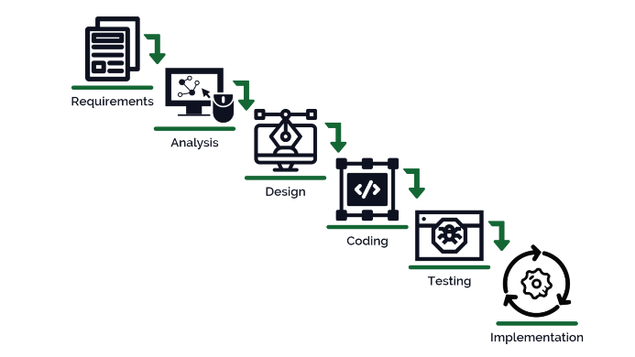

- System Requirements

- Hardware Requirement

- Laptop or PC
- Windows 7 or higher
- I3 processor system or higher
- 4 GB RAM or higher
- 100 GB ROM or higher

- Software Requirement

- Laptop or PC
- Visual Studio 2019
- SQL Server Management Studio’s latest

- Limitation/Disadvantages
- However, if a transaction problem arises, it must be reported to the banks and may take some time to fix.

- Application – This application connects merchants to banks and their services, reducing transaction time.

- Reference
- https://www.researchgate.net/publication/322924318_A_STUDY_ON_PAYMENT_AND_SETTLEMENT_SYSTEM_IN_INDIAN_BANKING_SECTOR
- https://www.researchgate.net/publication/294426662_Financial_market_Infrastructures_A_study_on_Payment_and_settlement_system_in_India_banking_sector
- https://www.bis.org/cpmi/publ/d22.pdf
- https://www.ecb.europa.eu/pub/pdf/other/glossaryrelatedtopaymentclearingandsettlementsystemsen.pdf

